**High Level Diagram:**

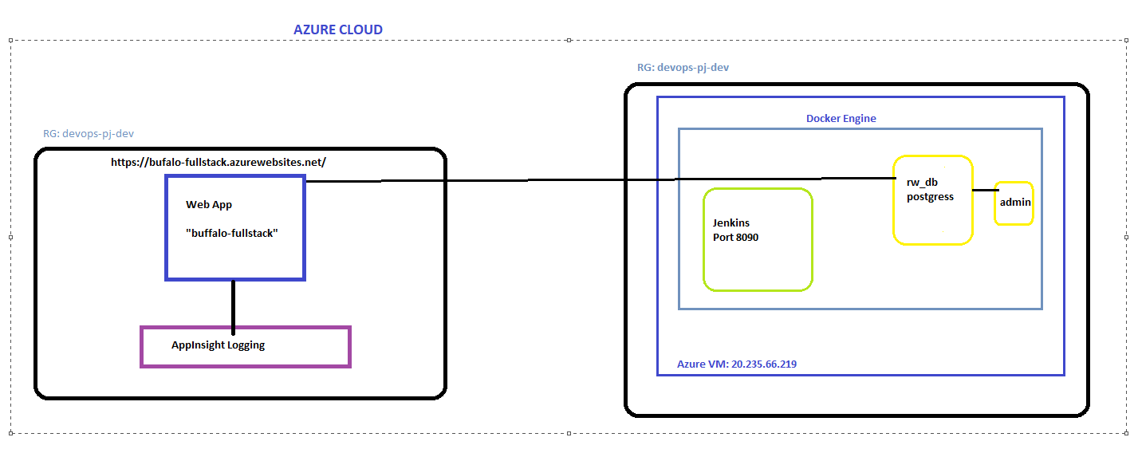

* Jenkins server is deployed on <http://20.235.66.219:8090/>
* Conduit app is running on azure webApp service: [https://bufalo-fullstack.azurewebsites.net](https://bufalo-fullstack.azurewebsites.net/)
* Postgress db is running on a digital ocean droplet machine alongside adminer to view

data on db : 20.235.66.219:5432 [username:password postgres: postgres] [dbName: gobuff_realworld_example_app_production]

**Jenkins jobs:**

* [devops-pj-1](http://20.235.66.219:8090/job/devops-pj-1/)

o This job first cleans workspace, note down the git hash

* + Then build image and push to the registry amit0wadhiani/bufalo-fullstack with tags ${env.BUILD_NUMBER} & ${commit_id}
  + Then creates db on Azure VM using docker-compose and waits for 30 seconds for the db to comeUp
  + Then it uses armTemplates to create resources on azure cloud mainly a webApp with docker image built in the previous step and appinsights for logging the app logs.
  + Cleans the Jenkins workspace
* [DB-Backup](http://20.235.66.219:8090/job/DB-Backup/)
  + backup is done using command line (The backup file can be further pushed to a cloud storage in part of the job)
  + This job is using the docker container running on host for the creating a backup and then moving it to a different place. Steps:
    - sshpass -p $pass ssh root@20.235.66.219
    - docker exec -t rw_db pg_dumpall -c -U postgres > postgres_dump.sql
    - mv ./postgres_dump.sql

/var/jenkins_home/postgressBackup/postgres_dump-

${env.BUILD_NUMBER}.sql

* [dockerCleanup](http://20.235.66.219:8090/job/dockerCleanup/):
  + This job cleans up the orphan images, containers and networks on docker server.